SAMPLE School Outdoor Air Quality Protocol
The following protocol for modifications and/or restrictions of physical activity in schools may be followed based on Air Quality Index (AQI). Please confirm with the district administration before finalizing this protocol.

Air Quality and Physical Activity
At the start of the school year, all students with increased risk, if exposed to poor air quality, should be identified. This group includes all students with chronic lung disease (including asthma) and cardiac disease.

Verification of Air Quality
A delegated staff member will review (per district) the Air Quality Index established daily by the AirNow.gov air quality report by visiting the website: AirNow.gov and transmitting this information to the appropriate district personnel (i.e. school nurses, administrators etc.). AirNow uses the official U.S. Air Quality Index (AQI), a color-coded index designed to communicate whether air quality is healthy or unhealthy.
Steps to take to review your area’s Air Quality Index:
- Input the district zip code in the search box on AirNow.gov website and click “go”
- Review information provided for the district zip code

Air Quality Index
The American Lung Association modified the advisory section of the AirNow index:
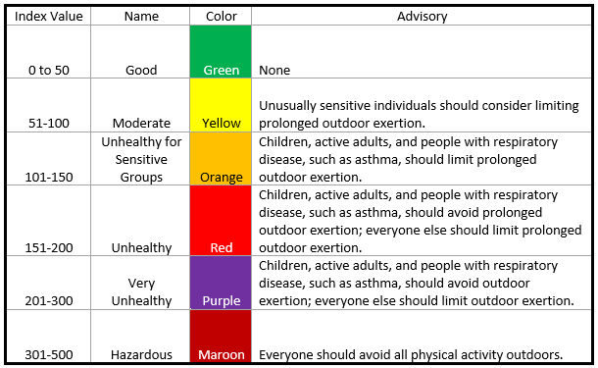
Air Quality Index | American Lung Association

District Plan
The district should develop a plan for the index values that may be detrimental to students with chronic lung disease (including asthma) and cardiac disease. These plans should not segregate students (i.e.: if some students have to stay inside, all students must stay inside) unless the affected student’s parent/guardian approves the plan for their child to stay indoors due to air quality when their classmates go outside.
Sample District Plan
Green | Nice day to go outside.
Yellow | Ok, to go outside and be active for recess/PE class. Watch for symptoms in students identified to have increased risk.
Orange | Ok, to go outside and be active for recess/PE class. Watch for symptoms in students identified to have increased risk.
Red | Take it easier when doing outside activities. Be active for shorter amounts of time outside.
Purple | It’s a good day to play inside. If outdoor activities have to happen, plan for morning activities.
Maroon | Everyone should avoid all physical activity outside.
Information in the above table referenced from NJ Air Quality Flag Program

Notification Procedure
In the event that air pollution levels exceed federal clean air standards, a health advisory or ozone warning is issued, or an air pollution episode is declared by the New York State Department of Health or your local county/city health department – school administrators should:
- Alert teachers, staff, and all other site users regarding the implementation of health advisory; and
- Observe appropriate physical activity restrictions.

